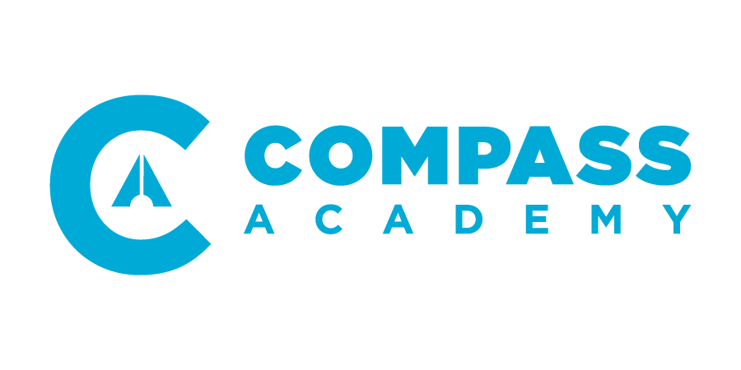

1.4 Questionnaire

Student Name:

- About this Course

Thank you for completing this Team leadership course with us! We value you and your leadership here at Compass. We also value your opinions/insights. What suggestions do you have regarding ways in which we could improve on this Team Leadership course in the future? What could we do differently?

- About Compass Academy Year 1

- Please rank your favorite/least favorite course during Yr1 and explain why

- CA1 Compass Leadership:

- CA2 Self Leadership:

- CA3 Pastoral Leadership:

- CA4 Team Leadership:

- How would you describe Compass Academy?

- How would you rank your understanding of the following compared to the start of CA? Please select one of the 4 labels (1- worse, 2 – the same, 3 improved slightly, 4 – improved significantly) for each element.

 | 1  Worse | 2  Same  (no change) | 3  Improved slightly | 4  Improved significantly
Compass Ministries and Operations

Compass Goals and Philosophy

Self-leadership

Differences between biblical/spiritual leadership and other forms of leadership
The role of a pastoral leader

Team leadership

Your leadership competency

Confidence in serving/leading at Compass

- What has been the most rewarding aspect about Compass Academy for you?

- Would you recommend Compass Academy? (Please explain your answer)

- You do plan to complete Compass Academy Year 2? Y/N

Thank you!

